Welcome to Visual Learning

~ User Documentation

# Getting Started

Visual Learning is an application aimed to help beginners enhance their understanding about Insertion Sort (see <https://www.geeksforgeeks.org/insertion-sort/> ) by a Visual representation of the various steps a given set of numbers, or strings undergo. It aims to help students visualize and gain a greater in-depth understanding of the sorting process behind insertion sort.

# Hello 🡪 First Intro Form

The program opens with a small window as shown below

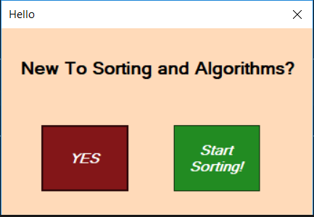

Pressing “YES” will redirect you to a webpage with relevant information on sorting algorithms for beginners.

Pressing “Start Sorting!” redirects the user to the main interface

# Visual Learning Interface

The interface consists of 6 button controls and an input textbox.

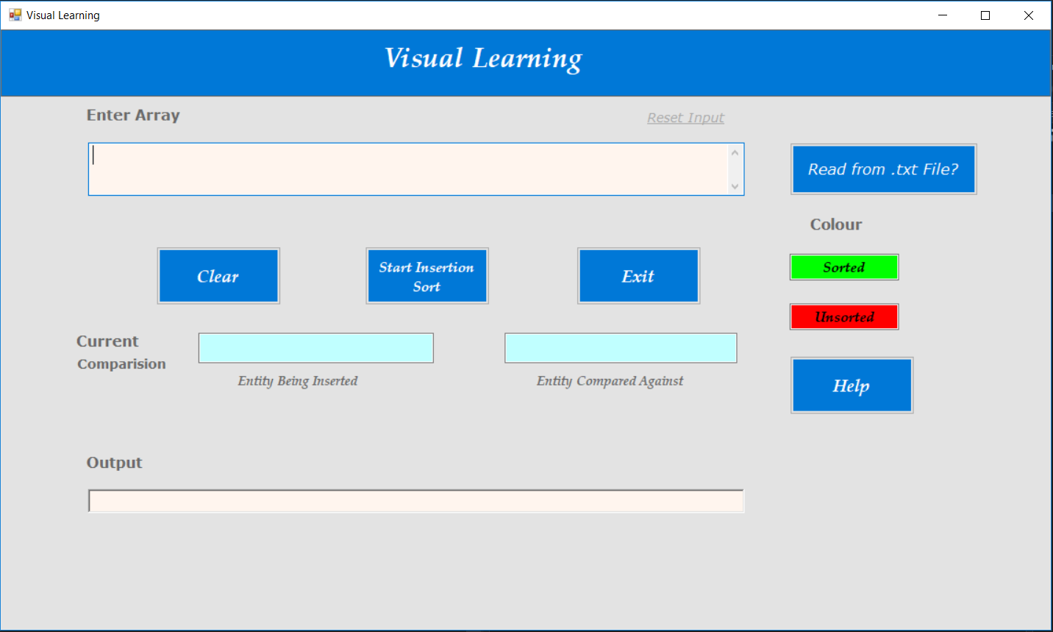

## Giving Inputs

Inputs can be given in two ways –

* Keyboard
* From an external Text file (.txt) loaded from the computer

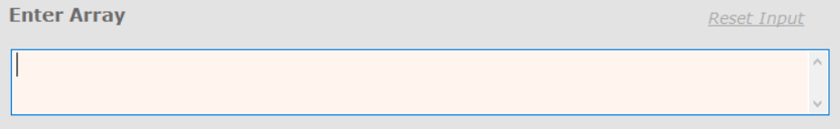

The cursor is automatically set to the start of the Input textbox and the user can Give in inputs via keyboard.



Caution: Input should be all space separated Decimals or all Strings



To take input from a text file press the “Read from .txt File?” button. This will redirect the user to a Window where the user can navigate within his machine and select the required text file

Caution: Open only Text (.txt) files

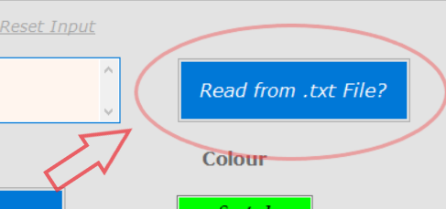

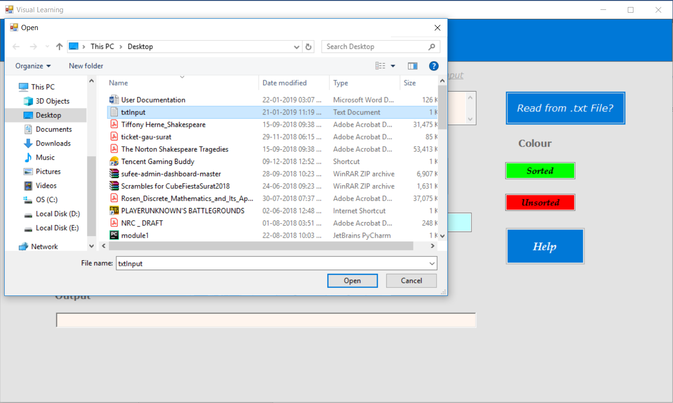

To ‘restart’ or clear given input, press the “Reset Input” option found top right of the Input textbox.

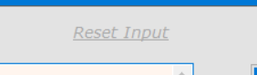

## Running Your Sort

After giving desired inputs, User can start sorting by pressing “Start Insertion Sort” button or by pressing Enter (Return Key) on their Keyboard.

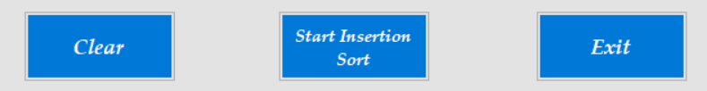

## Understanding the different Outputs Generated

Two main segments of outputs are generated, namely –

* Current comparisons, and
* Partial Output at each step

### Current Comparisons

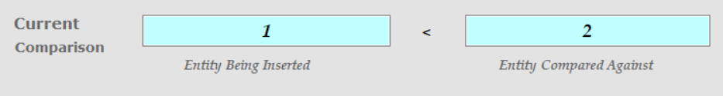

The current comparisons section shows Two entries –

1. Entity being Inserted
2. Entity it is being compared with(against)

Say a particular iteration has sorted segment as - 2 3 4

And the next integer to be inserted is say, 1. Then in a single iteration, 1 will be compared with 4->3->2 and then placed in the first position.

This section shows all these comparisons per run at an interval of 0.5 seconds, and stops when element is inserted in its correct position. Try input – 5 4 3 2 1

### Output

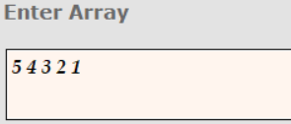

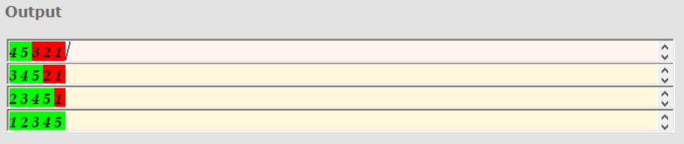

The output contains read only Textboxes that the user cannot manipulate.

Insertion sort Inserts elements into their correct places one by one. Therefore it gives us a partially sorted output in each iteration (Shown in GREEN ), and an unsorted part (Shown in RED )

Output section shows each step for a given input.

The user has to press the “Next Step” Button to print the next step and view the comparisons.

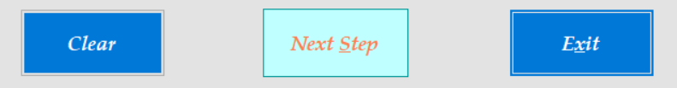

This button will only appear after starting the sort and disappear until a particular iteration is finished.

## Clear and Exit buttons

The clear button will reset all output to nil. And the Exit button can be used to Close the program.